**Лабораторна робота №2.2**

З дисципліни «Структури даних та алгоритми»

Тема: «Модулі»

Виконав: Землянський Едуард

Група: КВ-22

**Мета лабораторної роботи**

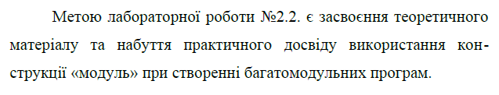

**Постановка задачі**

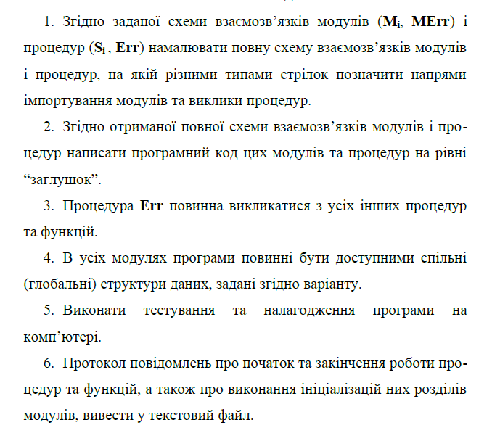

**Варіант завдання**

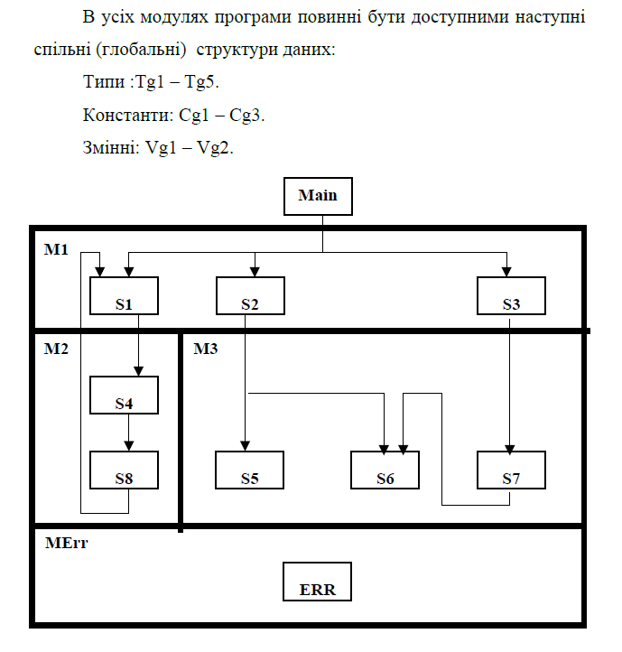

**Текст програми**

main.c

#include <stdio.h>

#include <stdlib.h>

#include "common.h"

#include "M1.h"

#include "MErr.h"

int main(){

    logs = fopen("logs.txt", "w");

    fprintf(logs, "Main started.\n");

    common_init();

    S1();

    S2();

    S3();

    MErr();

    fprintf(logs, "Main finished.\n");

    fclose(logs);

    return 1;

}

common.c

    #include <stdlib.h>

    #include <stdio.h>

    #include "common.h"

    #include "MErr.h"

    FILE * logs;

    typedef int Tg1, Tg2, Tg3, Tg4, Tg5;

    int Vg1, Vg2, counter;

    int const Cg1 = 10, Cg2 = 20, Cg3 = 30;

void common_init(void){

    logs = fopen("logs.txt", "a");

    fprintf(logs, "Common initialization started.\n");

    Vg1 = 1;

    Vg2 = 2;

    counter = 0;

    MErr();

    fprintf(logs, "Common initialization finished.\n");

}

common.h

#ifndef COMMON_H_INCLUDED

#define COMMON_H_INCLUDED

#include <stdio.h>

#include <stdlib.h>

typedef int Tg1, Tg2, Tg3, Tg4, Tg5;

extern int Vg1, Vg2, counter;

extern int const Cg1, Cg2, Cg3;

extern FILE *logs;

void common_init();

#endif

M1.c

#include <stdio.h>

#include <stdlib.h>

#include "common.h"

#include "M2.h"

#include "M3.h"

#include "MErr.h"

void S1(void){

    counter++;

    fprintf(logs, "S1 started\n");

    S4();

    MErr();

    fprintf(logs, "S1 finished\n");

}

void S2(void){

    fprintf(logs, "S2 started\n");

    MErr();

    // S5();

    // S6();

    fprintf(logs, "S2 finished\n");

}

void S3(void){

    fprintf(logs, "S3 started\n");

    MErr();

    // S7();

    fprintf(logs, "S3 finished\n");

}

M1.h

#ifndef M1_H_INCLUDED

#define M1_H_INCLUDED

#include <stdio.h>

#include <stdlib.h>

void S1();

void S2();

void S3();

#endif

M2.c

#include <stdio.h>

#include <stdlib.h>

#include "common.h"

#include "M1.h"

#include "MErr.h"

void S4();

void S8();

void S4(void){

    fprintf(logs, "S4 started\n");

    MErr();

    S8();

    fprintf(logs, "S4 finished\n");

}

void S8(void){

    while (counter < 3)

    {

        fprintf(logs, "S8 started\n");

        MErr();

        S1();

        fprintf(logs, "S8 finished\n");

    }

}

M2.h

#ifndef M2_H_INCLUDED

#define M2_H_INCLUDED

#include <stdio.h>

#include <stdlib.h>

void S4();

void S8();

#endif

M3.c

#include <stdio.h>

#include <stdlib.h>

#include "common.h"

#include "MErr.h"

void S4();

void S8();

void S5(void){

    fprintf(logs, "S5 started\n");

    MErr();

    fprintf(logs, "S5 finished\n");

}

void S6(void){

    fprintf(logs, "S6 started\n");

    MErr();

    fprintf(logs, "S6 finished\n");

}

void S7(void){

    fprintf(logs, "S7 started\n");

    S6();

    MErr();

    fprintf(logs, "S7 finished\n");

}

M3.h

#ifndef M3_H_INCLUDED

#define M3_H_INCLUDED

#include <stdio.h>

#include <stdlib.h>

void S5();

void S6();

void S7();

#endif

MErr.c

#include <stdlib.h>

#include <stdio.h>

#include "common.h"

void MErr(void){

    fprintf(logs, "MErr triggered\n");

}

Merr.h

#ifndef MErr_H_INCLUDED

#define MErr_H_INCLUDED

#include <stdio.h>

#include <stdlib.h>

void MErr();

#endif

**Логи** (після виконання програми)**:**

logs.txt

Main started.

zation started.

MErr triggered

Common initialization finished.

S1 started

S4 started

MErr triggered

S8 started

MErr triggered

S1 started

S4 started

MErr triggered

S8 started

MErr triggered

S1 started

S4 started

MErr triggered

S4 finished

MErr triggered

S1 finished

S8 finished

S4 finished

MErr triggered

S1 finished

S8 finished

S4 finished

MErr triggered

S1 finished

S2 started

MErr triggered

S2 finished

S3 started

MErr triggered

S3 finished

MErr triggered

Main finished.